Bridgette Edghill  
POL SCI 6402  
Int Techniques in Policy Research

**Exploring the Potential for Partisan Bias in Enforcement of Americans with Disabilities Act of 1990**

**Introduction**

Disability advocacy has had a long and winding road in the United States. While general knowledge of the Americans with Disabilities Act of 1990 (ADA) is widespread, the devil is in the details. With surface-level knowledge, it seems reasonable to ask the question are Democratic administrations more motivated to enforce the law than their Republican counterparts? Seeing as the Equal Employment Opportunity Commission (EEOC) implements Title I of the ADA, the executive branch does have a role to play – specifically when it comes to ensuring those with disabilities receive equitable treatment in the workforce. However, due to complicating factors the answer to this question, even 30 years on is as unclear as ever.

And yet, a question whose answer is so obscure is still a question worth asking. As discussed in a plurality of sources reviewed, the plight of the worker with a disability is a serious one. “The employment rate among the working aged disabled is 17 percent, compared with 65 percent of their non-disabled counterparts” (Maroto and Pettinicchio 2015). And past the sheer number of unemployed individuals lurks a more sinister figure – “8 in 10 disabled people were estimated not to be in the labor force in 2017, as compared with 3 in 10 without disabilities” (Sprong et al 2019). This is just a sample of the many alarming statistics concerning the difficulties of the disabled workforce.

**Historical and Literature Review**

As hinted at earlier, the ADA was not the first step on the journey for disabled rights. The first major piece of legislation was the Rehabilitation Act of 1973. While it was not as far reaching as its successor, it did allow room for the disability rights movement to grow (Rothstein 2015). Eventually, this culminated in President George H.W. Bush signing the ADA into law on July 26, 1990 (Hogan 2003).

Several parts of the federal government including Housing and Urban Development (HUD), the Department of Labor, and Federal Communications Commission (FCC), among others enforce different parts of the law (Carden and Boyd 2018). Since the EEOC already handled workplace discrimination for other protected classes, they seemed like a natural successor to enforce Title I (EEOC 2020). Indeed, they were able to apply the existing framework to this newest protected class. The structure of potential outcomes that can result from a charge is illustrated in the table below.

**Table 1.** Definitions of Conclusions of Charges made with the EEOC

|  |  |
| --- | --- |
| **Resolutions** | All charges closed in the administrative process, comprised of charges with no cause findings, administrative closures, and merit resolutions. |
| **Merit Resolutions** | Charges resolved with an outcome favorable to charging party or charge with meritorious allegations. These are comprised of negotiated settlements, withdrawals with benefits, successful conciliations, and unsuccessful conciliations. |
| **Monetary Benefits** | Various types of relief secured through administrative enforcement in the resolution of a charge of discrimination that have a financial valuation.  These include actual cash relief for charging parties or other aggrieved individuals such as restored pay, compensatory damages, punitive and liquidated damages, and other items such as attorney’s fees, fringe benefits, and training or tuition costs.  There is also prospective relief that may be included that is associated with the resolution of the charge including hiring, reinstatement, recall or other actions that result in employment for the charging party or aggrieved individuals, as well as promotions and prospective fringe benefits. |
| **Administrative Closure** | Charge closed for administrative reasons without a determination based on the merits, which include: lack of jurisdiction due to untimeliness, insufficient number of employees, or lack of employment relationship; charging party requests withdrawal without receiving benefits; or charging party requests the notice of right to sue. |

*Source:* Equal Employment Opportunity Commission 2020

With all the parts already in place, it seems that this would conclude in a satisfying happy ending. However, before the presidential preference could play a role in how much the law would be enforced, the courts intervened. In several cases, namely *Sutton v United Airlines* and *Toyota v Williams*, the courts strictly narrowed the definition of “disability” (Carden and Boyd 2018, Maroto and Pettinicchio 2015, Taylor 2016). This played a key role in how the law was applied, as most minutiae like definitions are left to the executive branch agencies (such as the EEOC) to decide. Indeed, the loose parameters for “disability” included in the ADA were sourced from the Rehabilitation Act of 1973 (Maroto and Pettinicchio 2015). Instead, with the courts’ interference, 90 to 92% of plaintiffs lost cases brought under the ADA (Lee 2001, Rothstein 2015).

As such, the EEOC’s enforcement or lack thereof of the ADA has been less a reflection of the political will of the sitting president and more of a push and pull between the courts and Congress. With this situation, the executive branch was “unable to enforce the spirit of the law as intended by Congress” (Lee 2001). Though political will can certainly play a role in enforcement of legislation, the executive branch must adhere to rulings handed down by the courts. As such, the EEOC had to follow court rulings on the narrow interpretation of the definition of “disability,” regardless of the desires of the president. However, there could be an argument made that passage of the ADAAA could have been pushed for by the president sooner as the courts’ narrow definition became clearer.

Instead, the original sponsor of the ADA Senator Thomas Harkin brought the Americans with Disabilities Act Amendment Act of 2008 (ADAAA) up in the legislature independently. This rectified the situation and made it so that the courts could not interfere to narrow the definition of disability again (Taylor 2016, Rothstein 2015).

Overall, enthusiasm for research on enforcement of the ADA has seen ups and downs. Closer to the passage of the legislation, there was an uptick of interest in the topic in academic circles. The same can be said for the period five to ten years after the ADA was passed, as there was movement to study how much of an effect it had. There has been some research periodically after that (especially surrounding passage of the ADAAA) but suffice it to say it has not been a hot topic in academia of late. So much so that it was noted by authors Michelle Maroto and David Pettinicchio (2015) who lamented “it is particularly surprising that disability is often excluded from general sociological studies of stratification and inequality.”

Unfortunately, with all of this complicated history, the testing of hypotheses becomes difficult. However, for the purpose of encouraging future research in this pivotal topic, they are as follows:

*Hypothesis 1:* There will be less resolutions finalized during Republican administrations.

*Hypothesis 2:* There will be more merit factor resolutions filed during Democratic administrations that are successors to Republican administrations.

*Hypothesis 3:* The monetary benefits assessed will be lower during Republican administrations.

The idea that Republicans would be less incentivized to protect protected classes is founded in key maneuvers that have been made by the party over the years. For example, the first attempt at the Rehabilitation Act was vetoed by (Republican) President Nixon (U.S. Congress 1973a). Then there were serious concerns that Bush may not even agree to sign the ADA into law (Shapiro 1993). Also noteworthy is that the sponsors of both forms of the Rehabilitation Act, the ADA, and ADAAA were all Democrats (U.S. Congress 1973a, 1973b, 1990, 2008). Even as the ADA neared passage, there were concerns among business interests that there would be high costs to accommodate those in need and an attempt to dictate to them who to hire (Lee 2001). These are just a few attempts and rationales given by conservative forces to circumvent protecting disabled rights.

**Data**

The primary source of data is the EEOC’s Integrated Mission System (IMS). This is an industry-wide standard for data and research use on this particular topic (Carden and Boyd 2018, Lee 2001, McMahon et al 2008). Fortunately, this database is easily accessed via the EEOC website (EEOC 2020). For context, the IMS was a project that was undertaken in FY 2004 which allows for a case to be filed with a state EEOC branch and for that case to be reflected on the federal level and vice versa (EEOC 2020). Although the collection of statistics began in 1997, all those prior to 2004 would have only included cases that were filed through the federal EEOC. Taking the whole database into account, we have the following at our disposal:

|  |  |  |  |
| --- | --- | --- | --- |
| **Years** | **n** | **President** | **Political Party Affiliation** |
| 1997-2000 | 3 years | William J. Clinton | Democrat |
| 2000-2008 | 8 years | George W. Bush | Republican |
| 2008-2016 | 8 years | Barack H. Obama | Democrat |
| 2016-2019 | 3 years | Donald J. Trump | Republican |

|  |
| --- |
| * *Note:* The act was signed into law by George H.W. Bush in 1989. He is not covered above since statistics were not recorded at the time. The statistics also cover only part of Clinton’s term which ran from 1992-2000. |

As shown in this table, there is a small N of 23 years. This will have to be earmarked while conducting the regression analysis, as the results will have larger potential standard errors due to multicollinearity, among other challenges.

The independent variable was either the presidential administration or the political party of the presidential administration with breakdown by administration the preferred variable type. The dependent variables for this study were number of resolutions and merit factor resolutions, total monetary benefits assessed (in millions of U.S. dollars), and average monetary benefits assessed (in U.S. dollars). For breakdown by disability, the dependent variable was slightly altered to assess each dependent variable by disability. Also, for this closer look at the data total monetary benefits were examined in thousands as opposed to millions of U.S. dollars The categories of disability that were called out for the purposes of further analysis were:

Orthopedic and Structural Impairments of the Back, Autism, Depression, Anxiety, Hearing Impairment, Vision Impairment

These categories are, quite frankly, a rabbit hole. And yet, interest groups for various disabilities such as the National Association of the Deaf or the American Heart Association could find this breakdown handy. This is because it shows them exactly how much more successful plaintiffs of their target disability are after passage of the ADAAA (see figures 4 through 7). At some point in the future, it could also give them an idea as to whether or not there is a partisan bias for or against their primary focus.

Also taken from EEOC records were staffing and budget allotted, as these can be indicative of potential presidential compliance. While the EEOC was the main source of data, additional information was culled from U.S. Bureau of Economic Analysis (BEA) to control for GDP and inflation for monetary figures (U.S. Bureau of Economic Analysis 2020).

Worth a quick mention is larger societal acceptance of certain kinds of disability being part of the error term. There has been increased discourse surrounding “invisible disabilities” (Maroto and Pettinicchio 2015) and a shifting view on acceptance fo those with a variety of developmental disabilities. And while this acceptance can help us grow as a society, it does not translate directly to jobs for all those who are disabled and unemployed (U.S. Department of Labor 2019). But, it does play a role more for some specific categories of disability than others.

**Model and Diagnostics**

For an initial review, a standard bivariate OLS regression was assessed with party as the independent variable. (All results described are detailed in the RScript.) Each presidential administration was then dummied out, with President Trump’s administration used as the reference category. These dummy variables were run using a multiple linear regression analysis.

Controls were then added on so as to account for any potential interference that could be quantified. This included the aforementioned GDP (coded in script as ‘GDPA’), differences in budgeting (‘DiffBudget’) and staffing (‘DiffStaff’). There wasn’t a straightforward way to account for court interference pre-ADAAA and meaningfully separate out executive branch partisanship in the data. It was substantively accounted for where possible, though not statistically so.

Deaf/hard of hearing charging parties were used as an example breakout disability category. This analysis used the dummied out presidential administrations as the independent variable and also controlled for GDP along with differences in budgeting and staffing.

It is imperative to note that multicollinearity was an issue for the independent variables broken down by administration. Clinton, Bush, and GDP in particular were all over ten in their VIF figures. Well in excess of the desired bounds surrounding the number two. Obama was not quite as exaggerated, but still over the extreme end of four at 6.45. Controls for difference in staffing and budget did not suffer from this issue. This analysis applies to both the overall and the subcategory Deaf/Hard of Hearing reviews. Considering the earlier described issue of the courts’ interference, this is not a complete shock. When checking multicollinearity for the independent variable for party, we see that this issue is abated. Essentially, this means that administrative breakdowns must be taken with a grain of salt at this time.

Fortunately, the main issue with linear regression is here. Autocorrelation is also fortunately not an issue for this analysis. Most of the administrative breakdown D scores were right around two at 1.67 (resolutions), 1.34 (merit resolutions), 1.47 (total monetary benefits assessed), and 2.002 (average monetary benefits assessed). Though, there is statistical significance for all dependent variables aside from average monetary benefits assessed. This is easily rectified with a quick run of the Cochrane-Orcutt procedure. This results in not only non-significant p values, but better D scores for two of the three dependent variables (the exception being resolutions, though it’s only a change to 1.63 and as such is far from troubling.)

**Results**

When the standard bivariate OLS regression model was applied, the only statistically significant dependent variable was resolutions (coded as ‘Rslv’ in the script) at the .05 level. This dependent variable also featured the only absolute value greater than 2 of the set at 2.38. The standard error for the average monetary (coded as ‘AvgMon’ in script) was very high relative to the coefficient estimate at 1604.48 and 77.93, respectively. This situation along with the poor fitting R squared measures indicate that further analysis is appropriate.

The dummy variables for presidential adminstrations were then applied and outside of the average monetary dependent variable, all dependent variables returned multiple statistically significant results. Not all of those statistically significant results belonged to the Republican presidential administrations. It is also worth noting that all had relatively strong fits (above .60) with the exception of the average monetary settlement dependent variable.

Beginning with resolutions, all administrations returned statistically significant results. Clinton, George W Bush (labeled in script as ‘WBush’), and Obama were all negative values compared to a strong coefficient estimate of 28,909 for the intercept, Trump. Though, we can see where the ADAAA begins to have an effect, as Obama was not statistically significant in his results, unlike his predecessors. Merit resolutions (coded as ‘Chrg’ in script) tell a similar story with statistical significance for Clinton, Bush, and Trump. The coefficient estimate for Trump is a somewhat lower (but still quite large) 5,706. Obama is not only not statistically significant, but also has a coefficient estimate at -252.75.

Since there are controls that are later added in for GDP, a deep dive on the monetary amount issued will be bypassed for now. The average monetary amount awarded will also benefit from this control, but it is interesting to peek at the results all the same. Trump’s administration awards quite a bit more on average to those who won a settlement at a coefficient estimate of $20,783.72 than Clinton (-$5,977.38), Bush (-$4,466.03), and Obama (-$2,000.24.) It is interesting to see these three administrations compared to Trump so closely clumped together. For a detailed numerical breakdown see Table 2 and for a coefficient plot of each dependent variable see Figures 5-8.

Beginning with the resolutions, the controls were then taken into account. Both Bush and Trump are significant where none of the other measures were. As shown on Table 3, Bush’s results are particularly intriguing at a coefficient estimate of -12,773.44. The question here is, is the coefficient estimate so dramatically low because public faith in successful appliance of the ADA had cratered? Or was this in part due to an attempt of Bush’s administration to discourage the filing of cases under Title I of the ADA? There is also the fact to consider that the IMS was implemented in 2004, so half of Bush’s term should have seen a boost from these state figures. And yet, his coefficient estimate lingers below Clinton’s -7516.71. Additionally, Obama does not see much of a post-ADAAA bump in registered resolutions as expected at -4,243.15. Trump’s previously strong figures weaken significantly after the addition of the controls, from a coefficient that was statistically significant at the .001 level to only at the .05 level. The merit resolutions follow more or less the same storyline as before the controls were introduced, though with weaker statistical significance than before.

The quirky storyline started with resolutions is continued with the dependent variable total monetary value assessed. GDP is significant, but not as strongly as anticipated. The real focus here is Bush’s coefficient estimate of -$39.38 million which did not benefit from the introduction of the control variables as much as Clinton and Obama. This again begs the question, were the courts so deeply limiting in their definition of “disability” that they account for most of this difference? This could feasibly be the case, as *Sutton* was handed down in 1999 and *Toyota* in 2002 (Taylor 2016). Though, it would not be a stretch to argue that in some part Bush’s administration was less than sympathetic to the plight of the disabled beyond passage of Medicare Part D.

Though, this trend is not carried over in the average monetary dependent variable. Trump’s administration, much like before the controls were introduced are statistically significant, though at a lower threshold (.01 as opposed to .001.) Both the difference in budgeting and staffing are statistically significant with the difference in budgeting dropping amount assessed by fourteen cents and staffing by a more considerable $15.75. This is the only time that these two controls are statistically significant across the dependent variables. So, while a lower budget and staff do not make a difference in the number of resolutions filed, merit resolutions decided, or overall monetary amount that is awarded, there is an impact on how much money is awarded on average to successfully charging party.

In our sample group of deaf/hard of hearing charging parties, dependent variable for total monetary amount awarded offers an interesting angle on the above discussion as shown on Table 4. Particularly that the coefficient estimate for the Trump administration is negative in this category. Obama, by comparison, has a positive coefficient estimate. This is some indication that there may be partisan bias when it comes to the total monetary amount awarded to the deaf/hard of hearing. This trend seems to continue with average monetary amount awarded. Again, GDP seems to factor in as anticipated. But, where Clinton’s coefficient estimate of 20,129.78 is positive, Trump’s is another negative coefficient estimate at -$31,768.87.

**Conclusion**

Thirty years on the ADA and ADAAA have not been the bulwark for the disabled many hoped for. The potential for the disabled to have increased quality of life that comes with gainful employment has been dashed. There are, however, positive trends post-ADAAA, even through President Trump’s administration.

There is unlimited (and exciting) potential for future research on this topic. Even though this paper could only scratch the surface, based on the relative recency of the passage of the ADAAA. But the ADAAA’s removal of the courts as a confounding variable will clarify the answers to the research question posed. For more immediate results, there is a possibility of comparison partisan influences on predecessors, such as the Rehabilitation Act of 1973. Weights may address some of the discrepancies in strength of enforcement allowed.

Another interesting approach to gauge potential partisanship over this issue would be a deeper dive into those who have had a hand in interpreting or crafting the pertinent law. Or asking who appointed the judges that handed down key rulings that became precedent. Or further still, reviewing the jurisprudence of the judges who limited the definition of “disability.”

Clearly, this is a multifaceted topic. Though it is one that is worth further exploration as we work toward a more equitable future for all disabled Americans in their respective fields of employment.

**Visualizations**

**Figure 1.** Line plot for Resolutions Filed per categorical disability

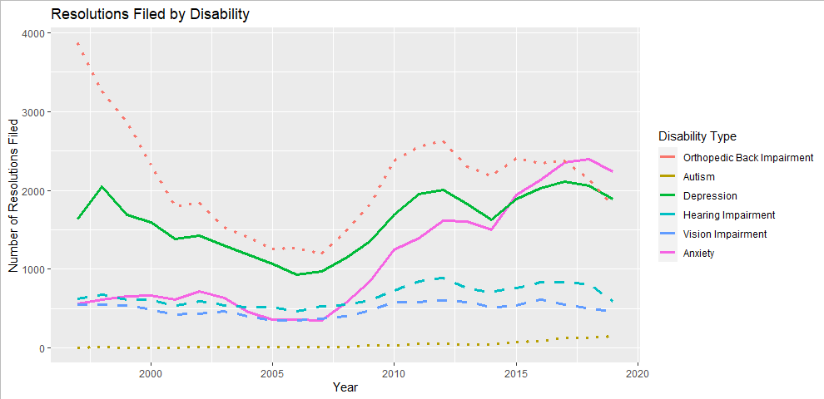

**Figure 2.** Line plot for Merit Resolutions Filed per categorical disability

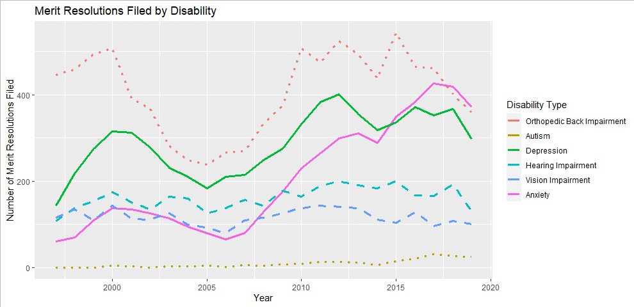

**Figure 3.** Line plot for Monetary Amount Awarded per categorical disability

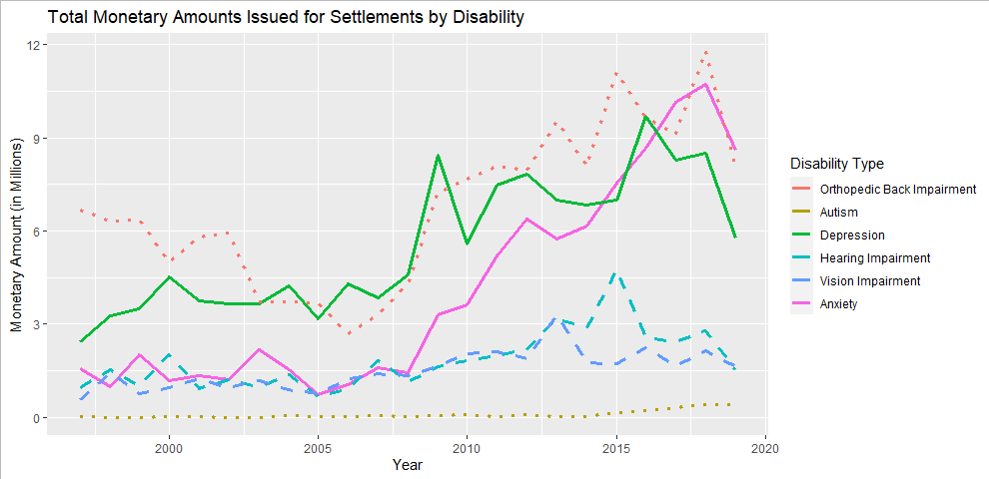

**Figure 4.** Line plot for Average Monetary Amount Awarded per categorical disability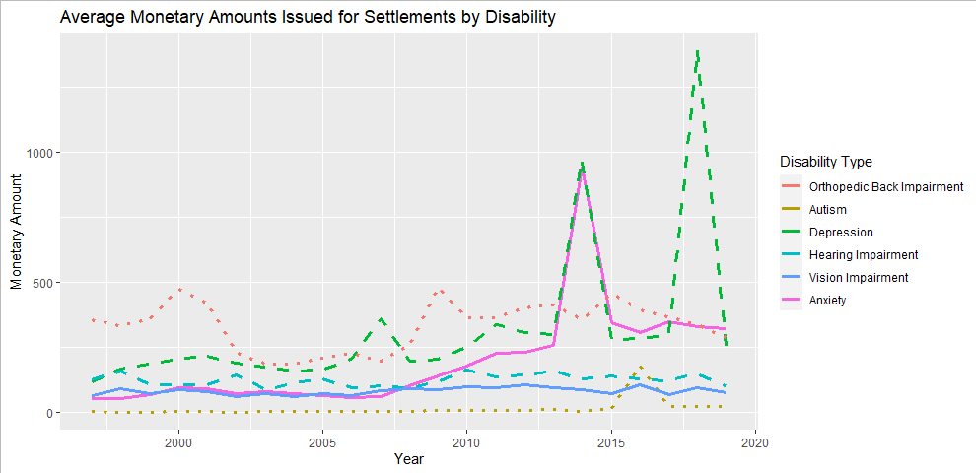

**Table 2.** Results of Multivariate Regression without Controls

| **ADA Results by Administration** | | | | |
| --- | --- | --- | --- | --- |
|  | **Resolutions** | **Merit Resolutions** | **Total Monetary Benefits (in Millions)** | **Avg Monetary Benefits (in Thousands)** |
| (Intercept) | 28,909.00*** | 5,706.00*** | 129.26*** | 20,783.72*** |
|  | (1,441.16) | (385.71) | (8.40) | (1,984.89) |
| Clinton | -6,371.25** | -1,917.75** | -77.94*** | -5,977.38* |
|  | (1,906.47) | (510.25) | (11.11) | (2,625.76) |
| WBush | -12,088.13*** | -1,837.00*** | -79.76*** | -4,466.03 |
|  | (1,689.91) | (452.29) | (9.85) | (2,327.48) |
| Obama | -2,946.00 | -252.75 | -27.36* | -2,000.24 |
|  | (1,689.91) | (452.29) | (9.85) | (2,327.48) |
| R2 | 0.80 | 0.66 | 0.84 | 0.28 |
| Adj. R2 | 0.77 | 0.60 | 0.82 | 0.16 |
| Num. obs. | 23 | 23 | 23 | 23 |
| ***p < 0.001; **p < 0.01; *p < 0.05 | | | | |

**Figure 5.** Coefficient Plot for ADA Filed Resolutions by Administration

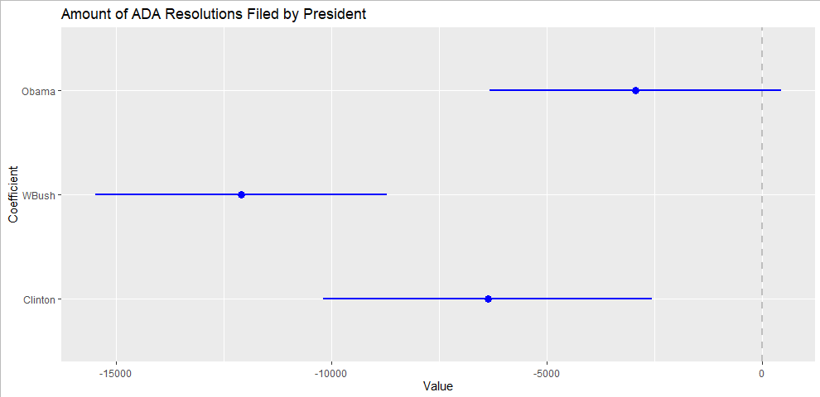

**Figure 6.** Coefficient Plot for ADA Merit Resolutions awarded by Administration

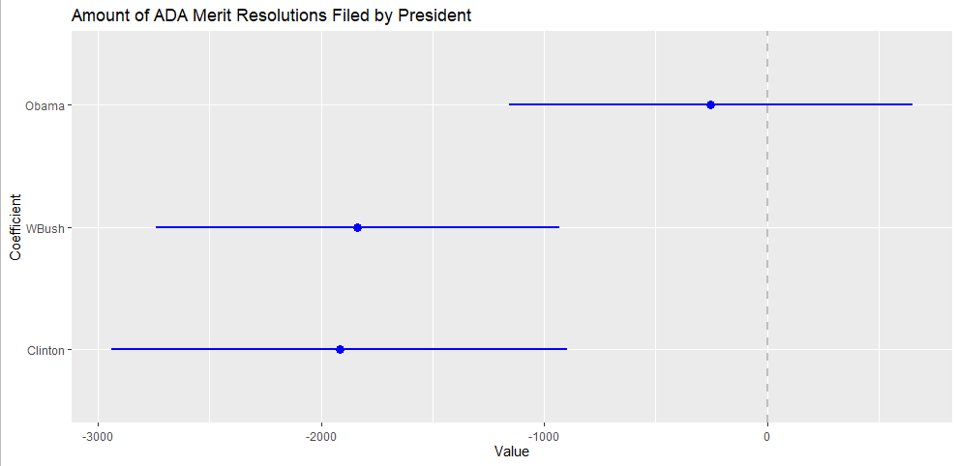

**Figure 7.** Coefficient Plot for Total Monetary Amount Rewarded by Administration

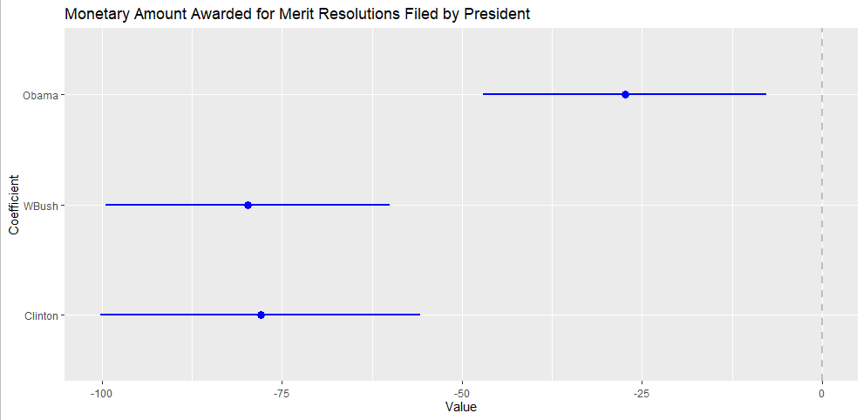

**Figure 8.** Coefficient Plot for Average Monetary Amount Awarded by Administration

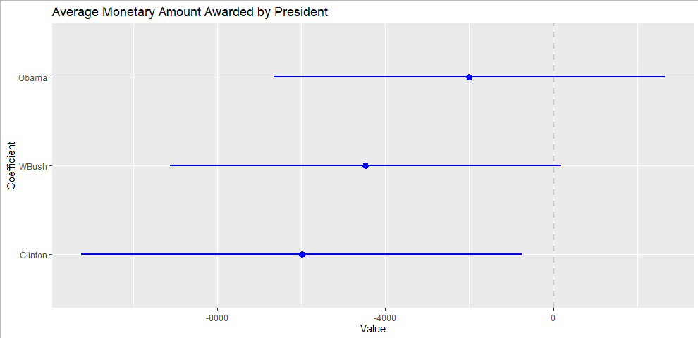

**Table 3.** Results of Multivariate Regression with Controls Included

| **ADA Results by Administration Controlling for GDP and Differences in Budget and Staffing** | | | | |
| --- | --- | --- | --- | --- |
|  | **Resolutions** | **Merit Resolutions** | **Total Monetary Benefits (in Millions)** | **Avg Monetary Benefits (in Thousands)** |
| (Intercept) | 29,220.15* | 6,799.87* | 22.71 | 41,484.56** |
|  | (10,312.01) | (2,595.35) | (48.62) | (12,409.24) |
| Clinton | -7,516.71 | -2,715.47 | -20.72 | -13,310.32 |
|  | (5,500.72) | (1,384.43) | (25.94) | (6,619.45) |
| WBush | -12,773.44** | -2,381.26* | -39.38 | -10,313.79 |
|  | (4,074.99) | (1,025.60) | (19.21) | (4,903.75) |
| Obama | -4,243.15 | -888.63 | -11.34 | -5,416.34 |
|  | (2,785.95) | (701.17) | (13.14) | (3,352.55) |
| GDPA | 0.07 | -0.02 | 0.01* | -0.81 |
|  | (0.46) | (0.11) | (0.00) | (0.55) |
| DiffBudget | 0.07 | 0.02 | 0.00 | -0.14* |
|  | (0.05) | (0.01) | (0.00) | (0.06) |
| DiffStaff | -3.98 | -2.04 | -0.03 | -15.75* |
|  | (5.93) | (1.49) | (0.03) | (7.14) |
| R2 | 0.83 | 0.74 | 0.91 | 0.53 |
| Adj. R2 | 0.77 | 0.65 | 0.88 | 0.36 |
| Num. obs. | 23 | 23 | 23 | 23 |
| ***p < 0.001; **p < 0.01; *p < 0.05 | | | | |

**Table 4.** Results of Multivariate Regression for Deaf/Hard of Hearing with Controls Included

| **ADA Results for the Deaf/Hard of Hearing by Administration, Controlling for GDP and Differences in Budget and Staffing** | | | | |
| --- | --- | --- | --- | --- |
|  | **Resolutions** | **Merit Resolutions** | **Total Monetary Benefits (in Thousands)** | **Avg Monetary Benefits (in Thousands)** |
| (Intercept) | 951.56** | 169.68 | -3,176,348.19 | -31,768.87 |
|  | (293.31) | (84.16) | (2,788,108.58) | (19,906.79) |
| Clinton | -242.34 | -21.22 | 2,056,897.01 | 20,129.78 |
|  | (156.46) | (44.90) | (1,487,257.31) | (10,618.86) |
| WBush | -305.39* | -18.26 | 959,501.48 | 11,685.92 |
|  | (115.91) | (33.26) | (1,101,775.35) | (7,866.56) |
| Obama | -61.37 | 17.60 | 1,486,777.27 | 11,029.72 |
|  | (79.24) | (22.74) | (753,250.97) | (5,378.13) |
| GDPA | -0.01 | 0.00 | 255.93 | 2.37* |
|  | (0.01) | (0.00) | (123.54) | (0.88) |
| DiffBudget | 0.00 | 0.00 | -1.30 | 0.01 |
|  | (0.00) | (0.00) | (13.46) | (0.10) |
| DiffStaff | -0.22 | -0.03 | 502.87 | 3.64 |
|  | (0.17) | (0.05) | (1603.77) | (11.45) |
| R2 | 0.77 | 0.52 | 0.63 | 0.60 |
| Adj. R2 | 0.69 | 0.35 | 0.49 | 0.44 |
| Num. obs. | 23 | 23 | 23 | 23 |
| ***p < 0.001; **p < 0.01; *p < 0.05 | | | | |

**References**

Americans with Disabilities Act of 1990, Pub. L. No. 101-336, 104 Stat. 327 (1990).

Americans with Disabilities Act Amendments Act of 2008, Pub. L. No. 110-325, 42 U.S.C. ch. 126 (2008).

Carden, Lila and Raphael Boyd. 2018. “Americans with Disabilities: A Plan to Reduce Claims.” *Southern Journal of Business & Ethics*. 10(2018): 10-16. https://search-proquest-com.ezproxy.umsl.edu/docview/2228574468?accountid=14595&pq-origsite=summon.

Hogan, Griff. 2003. *The Inclusive Corporation: A Disability Handbook for Business Professionals*. Athens, OH: Swallow Press/Ohio University Press.

Lee, Barbara A. 2001. “The Implications of ADA Litigation for Employers: A Review of Federal Appellate Court Decisions.” *Human Resources Management*. 40(1): 35-50. <https://doi-org.ezproxy.umsl.edu/10.1002/hrm.4014>.

Maroto, Michelle and Pettinicchio, David. 2015. “Twenty-Five Years After the ADA: Situating Disability in America’s System of Stratification.” *Disability Studies Quarterly*. 35(3). <http://dx.doi.org/10.18061/dsq.v35i3.4927>.

McMahon, Brian T., Richard Roessler, Phillip D. Rumrill Jr., Jessica E. Hurley, Steven L. West, Fong Chan, and Linnea Carlson. 2008. “Hiring Discrimination Against People with Disabilities under the ADA: Characteristics of Charging Parties.” *Journal of Occupational Rehabilitation*. 18(2008): 122-132. http://dx.doi.org/10.1007/s10926-008-9133-4.

Rehabilitation Act, S.7, 93rd Cong. (1973a).

Rehabilitation Act of 1973, Pub. L. No. 93-112, 87 Stat. 355 (1973b).

Rothstein, Mark A. 2015. “Innovations of the Americans With Disabilities Act Confronting Disability Discrimination in Employment.” *Journal of the American Medical Association (JAMA)*. 313(22): 2221-2222. https://jamanetwork-com.ezproxy.umsl.edu/article.aspx?doi=10.1001/jama.2015.3417.

Shapiro, Joseph P. 1993. *No Pity: People with Disabilities Forging a New Civil Rights Movement*. New York, NY: Random House.

Sprong, Matthew E., Kanako Iwanaga, Emili Mikolajczyk, Brianna Cerrito, and Frank D. Buono. 2019. “The Role of Disability in the Hiring Process: Does Knowledge of Americans with Disabilities Act Matter?” *Journal of Rehabilitation*. 85(4): 42-49. http://web.b.ebscohost.com.ezproxy.umsl.edu/ehost/detail/detail?vid=0&sid=952b6f51-29a5-4994-858c-feba71d3c278%40pdc-v-sessmgr05&bdata=JnNpdGU9ZWhvc3QtbGl2ZSZzY29wZT1zaXRl#AN=140999035&db=aph.

Taylor, Barry C. 2016. “The Americans with Disabilities Act: What the Legal Research Reveals About Trends and Unanticipated Applications of the Law.” Paper presented at the State of Science Conference on the ADA, Washington D.C.

U.S. Bureau of Economic Analysis. 2020. Gross Domestic Product [GDPA]. Retrieved from FRED, Federal Reserve Bank of St. Louis, https://stlouisfed.org/series/GDPA.

U.S. Department of Labor, Bureau of Labor Statistics. 2020. “Persons with a Disability: Labor Force Characteristics – 2019.” Bureau of Labor Statistics Press Office. https://www.bls.gov/news.release/pdf/disabl.pdf.

U.S. Equal Employment Opportunity Commission. 2020. “Americans with Disabilities Act of 1990 (ADA) Charges.” https://www.eeoc.gov/statistics/americans-disabilities-act-1990-ada-charges.

U.S. Equal Employment Opportunity Commission. 2020. “Definitions of Terms.” https://www.eeoc.gov/statistics/definitions-terms.